Aktivitätsblatt – Die einsame Insel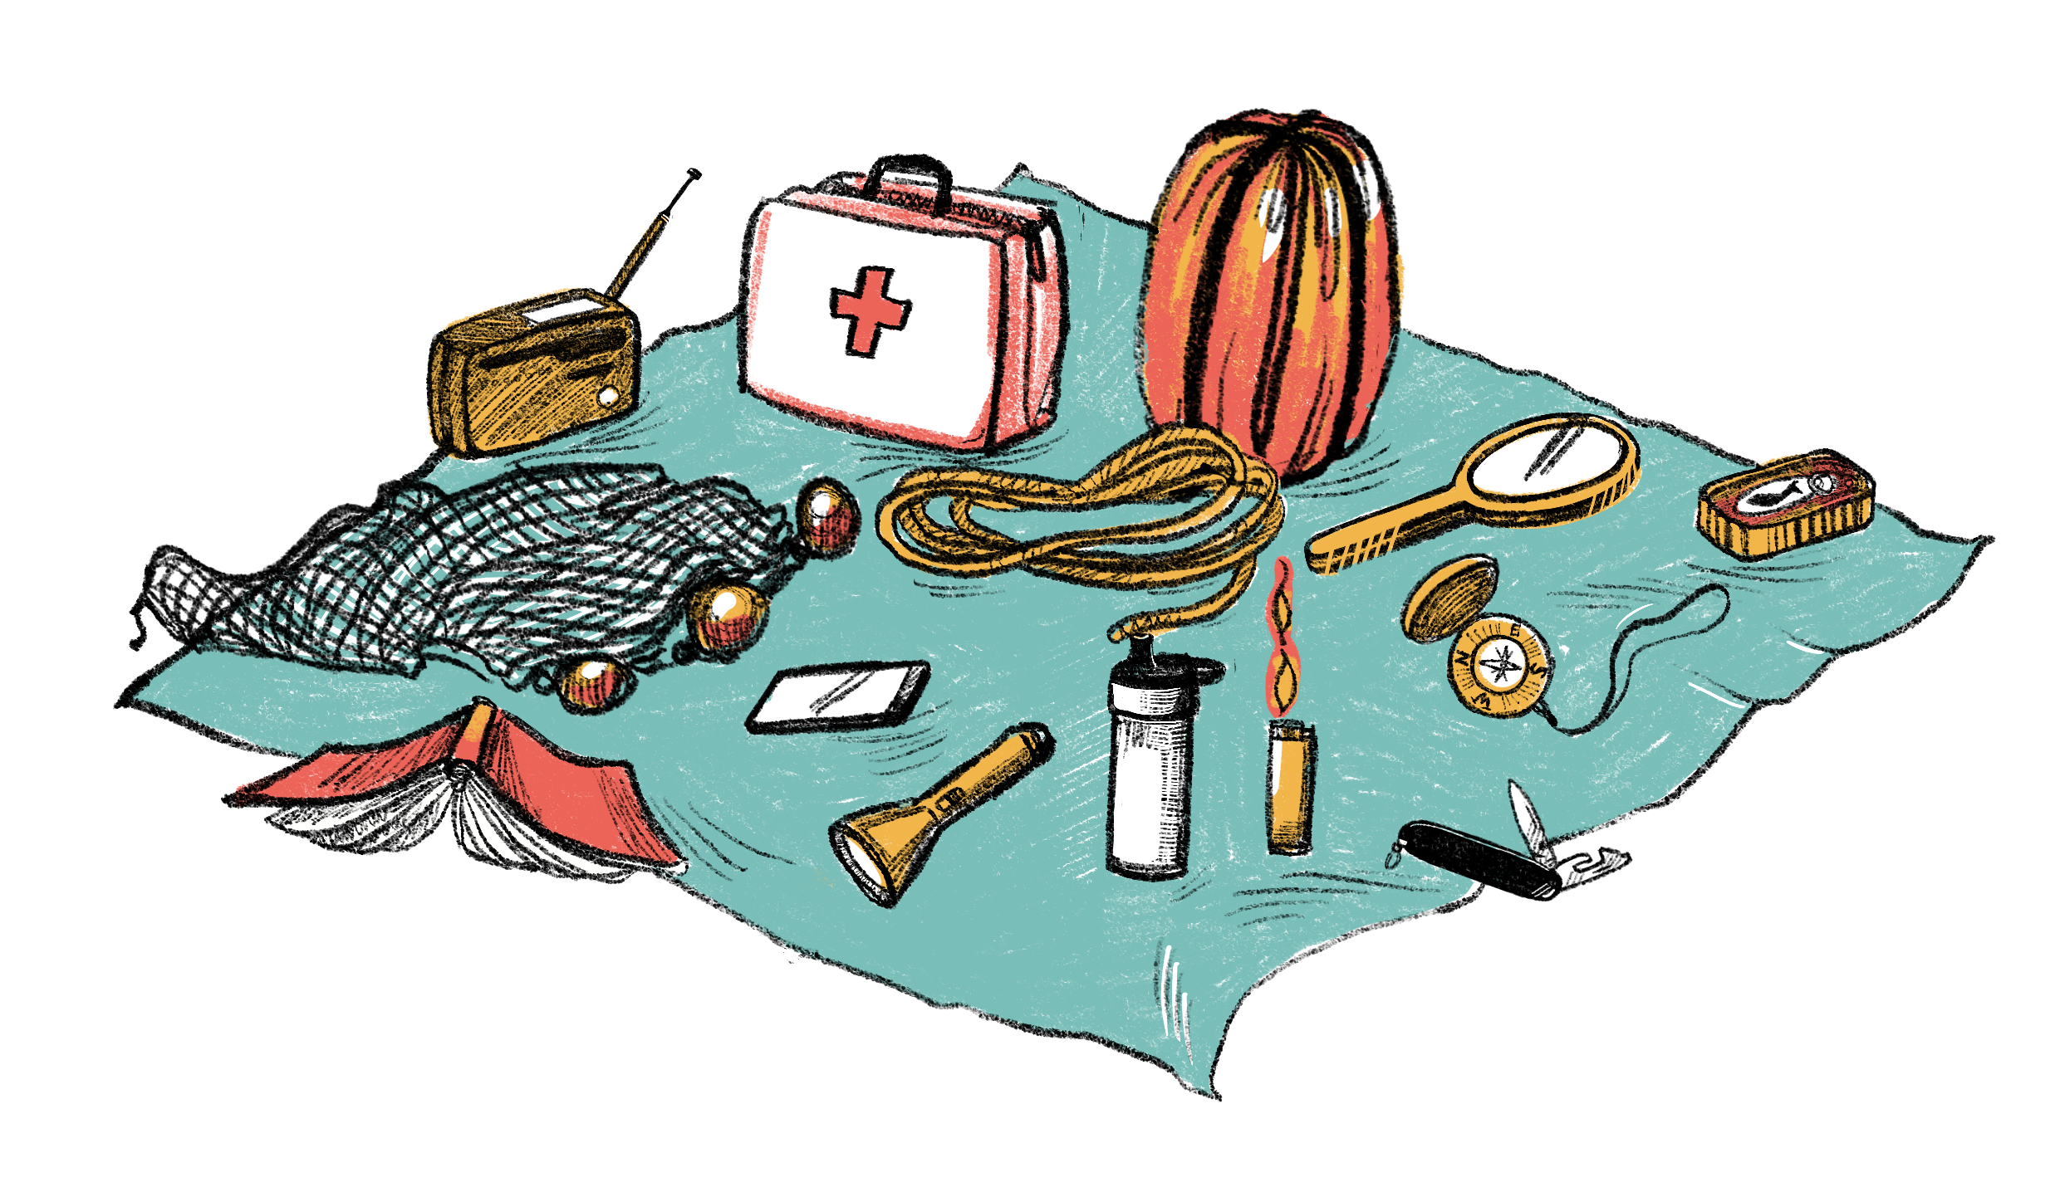
© Elodie Cachelin
Fischernetz | Buch | Taschenlampe
Solarradio | Handy ohne Netz | Plastikplane
Wasserfilter | Feuerzeug | Kompass
Schlafsack | Konservendose | Spiegel
Schweizer Taschenmesser | Seil (10 Meter) | Erste-Hilfe-Set

- __________________________________________________________________________
__________________________________________________________________________

- __________________________________________________________________________
__________________________________________________________________________

- __________________________________________________________________________
__________________________________________________________________________

- __________________________________________________________________________
__________________________________________________________________________

- __________________________________________________________________________
__________________________________________________________________________

