Fiche – L'île déserte
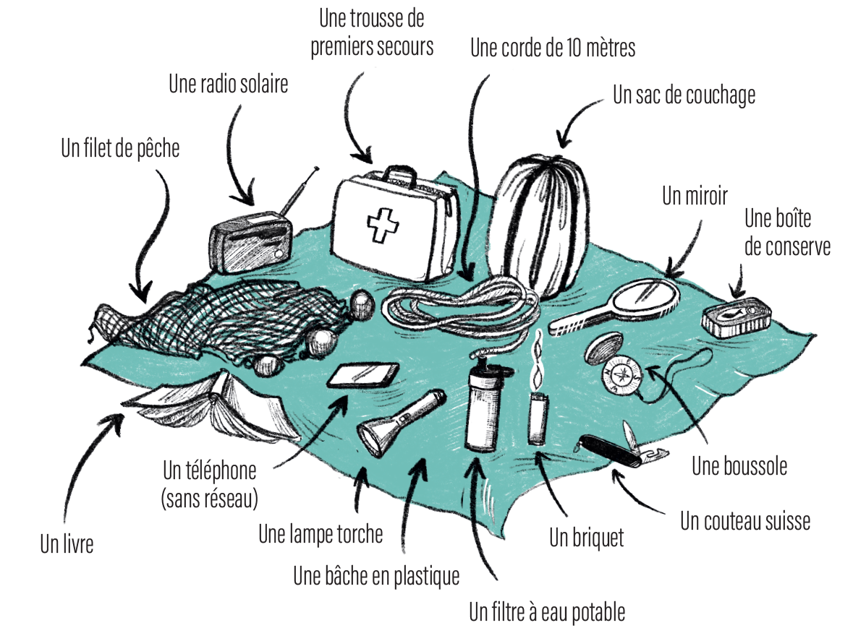
© Elodie Cachelin

- __________________________________________________________________________
__________________________________________________________________________

- __________________________________________________________________________
__________________________________________________________________________

- __________________________________________________________________________
__________________________________________________________________________

- __________________________________________________________________________
__________________________________________________________________________

- __________________________________________________________________________
__________________________________________________________________________

